MAIN PAGE

SIDING & SOFFIT
Industrial / Residential / Commercial
Enhance the aesthetic and functional appeal of your industrial, residential, or commercial property with our high-quality siding solutions. At Cladcan, we offer a wide range of siding materials designed to meet diverse architectural needs and performance requirements. Choose from an impressive selection of solid colors and realistic wood-look finishes to achieve the perfect visual effect for your project. Our products ensure durability, energy efficiency, and exceptional visual appeal, making them ideal for any building project.
Find the ideal match for your project with our impressive array of offerings!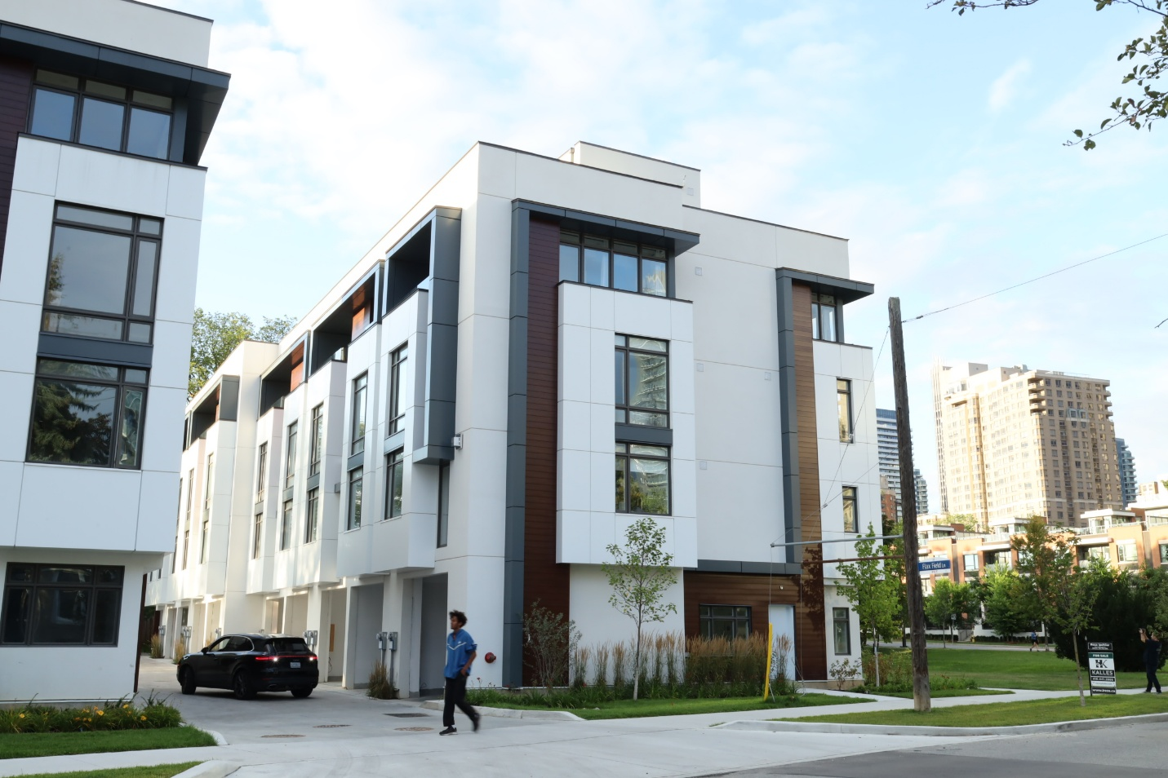

SIDING & SOFFIT MENU ICON (PREVIEW)

Aluminum Siding & Soffit
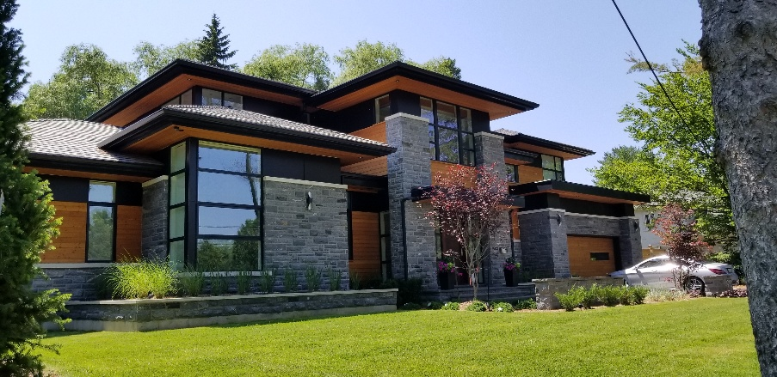
Our premium aluminum siding & soffit solutions are meticulously crafted to elevate both the aesthetic allure and structural fortitude of your project, seamlessly marrying elegance with practicality. (Learn More- Expand)
Expanded …Our aluminum siding & soffit boasts an extensive palette of colors and textures, providing robust protection against the elements while enhancing your build’s visual charm. Delve into our Aluminum panel choices to uncover how our cutting-edge siding options that can redefine your living & working spaces with enduring sophistication and effortless upkeep.
Curious about the advantages of aluminum siding? Visit our blog to explore the compelling reasons why this choice stands out for homeowners seeking durability and style.
Speak with an Expert
Get personalized advice and expert guidance to achieve your project goals with confidence.

2- FASPLANK MENU ICON (PREVIEW)

FastPlank Premium Siding & Soffit
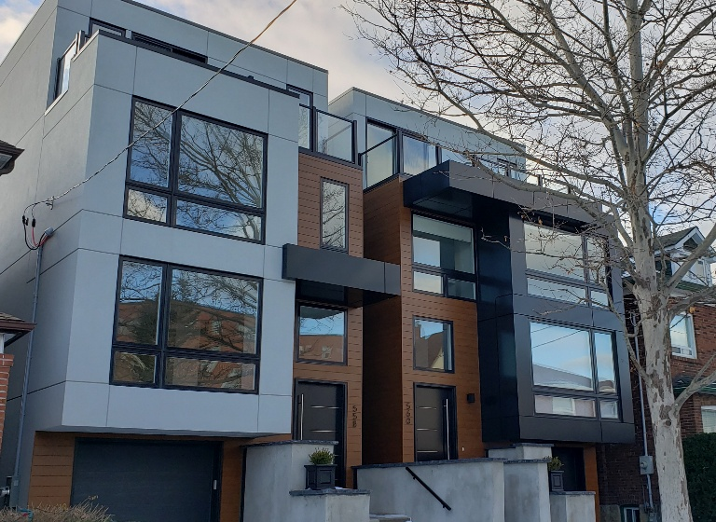
FastPlank® Systems offers a sophisticated and efficient aluminum plank siding solution designed to minimize the lead-time, streamline installation, enhance curb appeal, and provide long-term durability for building exteriors. (Learn More / Expand)

- 1 FASPLANK PAGE (EXPANDED)
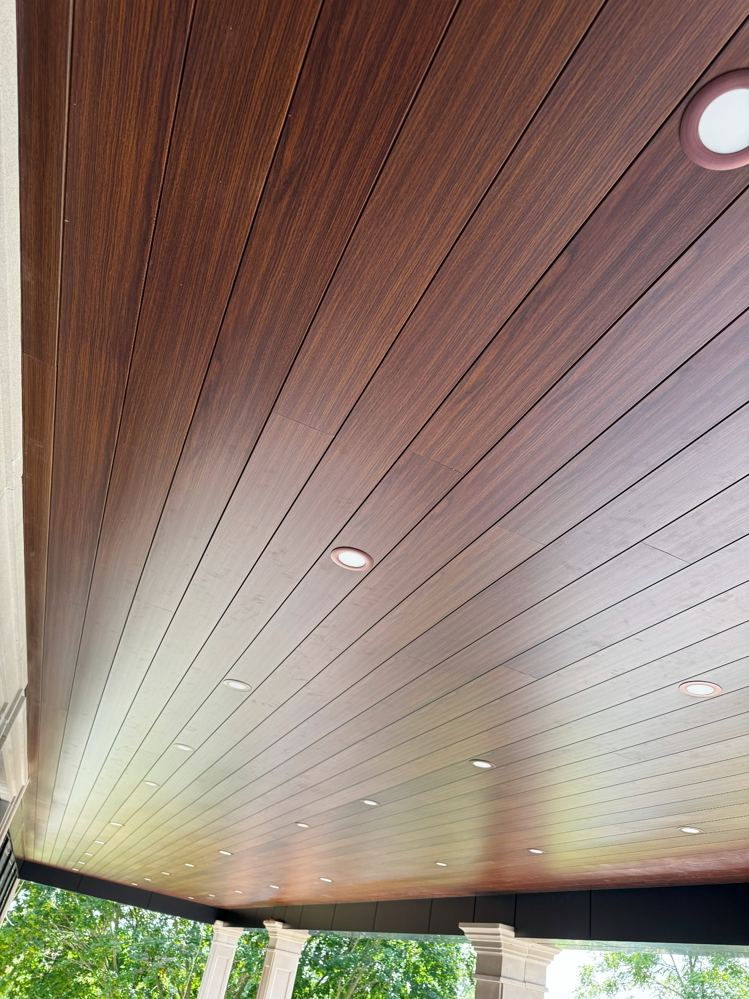
Expanded … FastPlank® Systems offers a sophisticated and efficient aluminum plank siding solution designed to minimize the lead-time, streamline installation, enhance curb appeal, and provide long-term durability for building exteriors.
Combining the timeless beauty of wood with the resilience of aluminum, FastPlank® eliminates concerns about weathering and deterioration, ensuring a pristine, low-maintenance finish for years to come.
Elevate your building’s facade with FastPlank®, creating a striking architectural statement with lasting value and refined aesthetics. Ideal as a replacement for fiber cement, vinyl, or wood siding, or as an accent feature, FastPlank® installs effortlessly. Its innovative design accommodates natural expansion and contraction, preventing gapping and buckling for a seamless, polished appearance.
Fast and Simple Installation

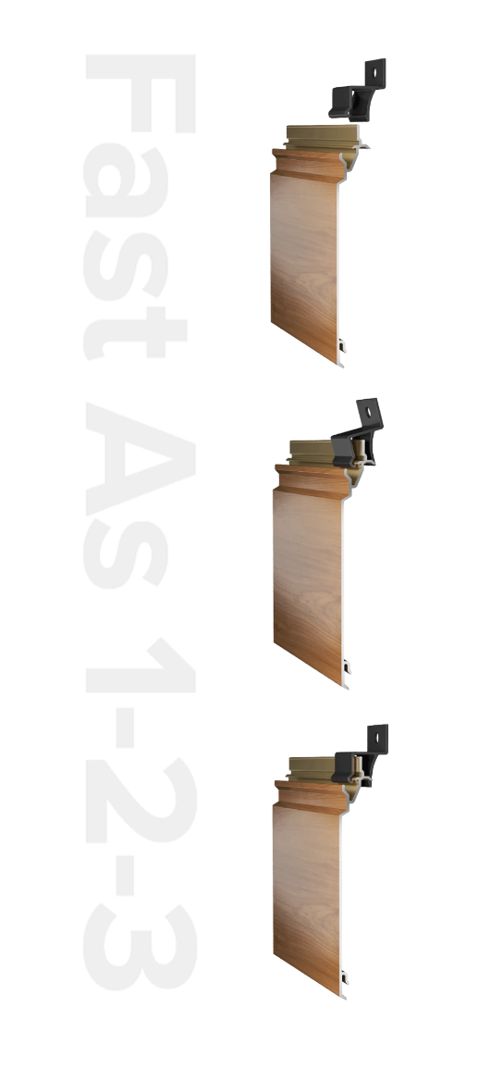
FastPlank® siding is designed for quick, hassle-free installation—no special tools or advanced skills required. Its innovative two-piece system uses a patented snap-together design to boost job site efficiency, save on labor, and deliver faster project completion.
Our Clip & Slide™ attachment system makes the process even easier. Just install the backplates, then snap the planks into place every 16 to 32 inches. It’s that simple.
The 16-foot planks are lightweight, strong, and easy to handle. Made from extruded aluminum, they cut cleanly and dust-free using a non-ferrous carbide blade.

Patented Innovation That Safeguards Your Investment
Non-Combustible
FastPlank® offers superior fire resistance and meets key safety standards, including California’s Wildland Urban Interface (WUI), ASTM E136, CAN/ULC S114, ASTM E84, and CAN/ULC S102.
UV & Fade Resistant
Built from premium 6063 T6 extruded aluminum, FastPlank® is powder-coated and treated to resist UV damage and fading—backed by a 20-year finish warranty.
Hail & Impact Resistant
FastPlank® has earned a Very Severe Hail (VSH) rating in third-party tests, showing no cracks or splits after impact from 2” ice balls at over 150 feet per second.
Built-In Rainscreen
Engineered as a pressure-equalized rainscreen, FastPlank® is AAMA 508-certified. Its smart design includes a 3/8” air cavity to exceed code requirements and effectively direct water away from the structure.
Corrosion & Salt Spray Resistant
Tested to ASTM B117-73 standards, FastPlank® is rust-resistant and anti-corrosive, certified under AAMA 1402-9—ideal for coastal or harsh environments.
Wind Resistant
Designed to withstand extreme weather, FastPlank® has passed wind load testing on multi-story buildings, ensuring strong performance and stability during high winds and storms.

Profile Options

P 44 V
Planks
V-Notch™ 4′′ Plank – A narrower plank (4” / 10.16cm) option with the standard V-Notch contour to create a well-connected cladding profile.
QTY per bundle: 10
Length: 16’ (192”) / 4.8768m (487.68cm)
FastPlank® Color Options
Available in a variety of woodgrain patterns and solid colors, or create any custom color with the ColorMatch® program.
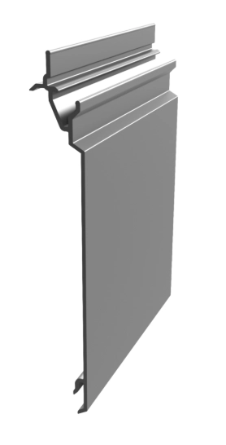

P 46 V
Planks
V-Notch™ 6′′ Plank – A broad plank option featuring the standard V-shaped notch contour to create a well-connected cladding profile.
QTY per bundle: 6
Length: 16’ (192”) / 4.8768m (487.68cm)
FastPlank® Color Options
Available in a variety of woodgrain patterns and solid colors, or create any custom color with the ColorMatch® program.

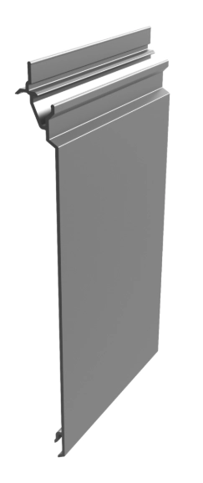

P 47 V
Planks
V-Notch™ 4′′ Perforated Soffit Plank – A perforated plank option for use on soffit applications, with the standard V-shaped notch contour to create a well-connected cladding profile.
QTY per bundle: 10
Length: 16’ (192”) / 4.8768m (487.68cm)
Net Free Air Space: 7.7 in2/ lin ft or 163.3 cm2/ lin m
FastPlank® Color Options
Available in a variety of woodgrain patterns and solid colors, or create any custom color with the ColorMatch® program.

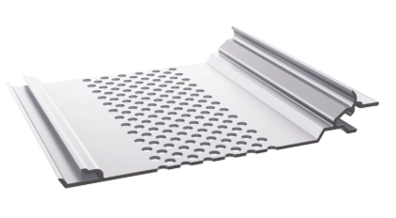

Trim Components
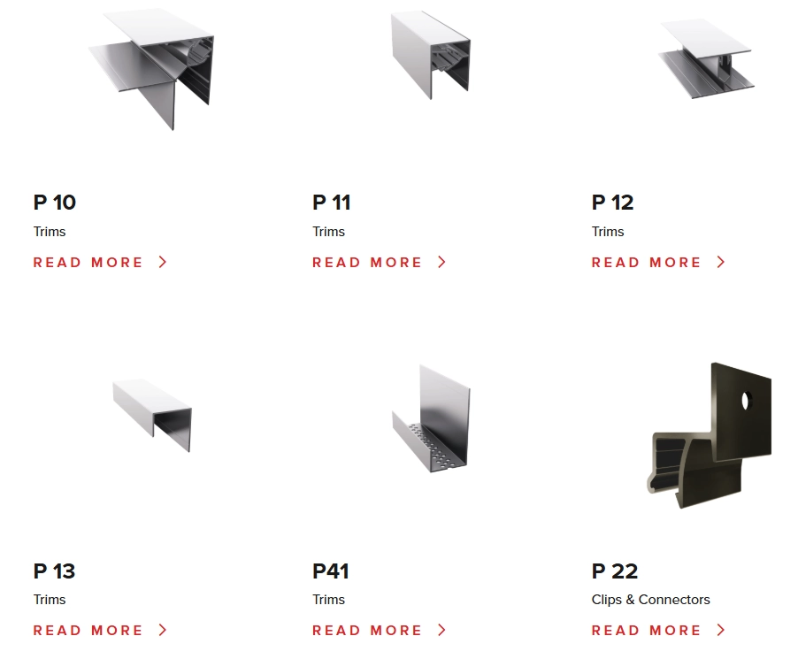

2-2 FastPlank Color Options
Select from a range of standard colours, realistic woodgrain finishes, or create a custom solid colour using the ColorMatch® system.
Every FastPlank® finish is built for long-term performance—durable, maintenance-free, and backed by a 20-year finish warranty and a 50-year product warranty.
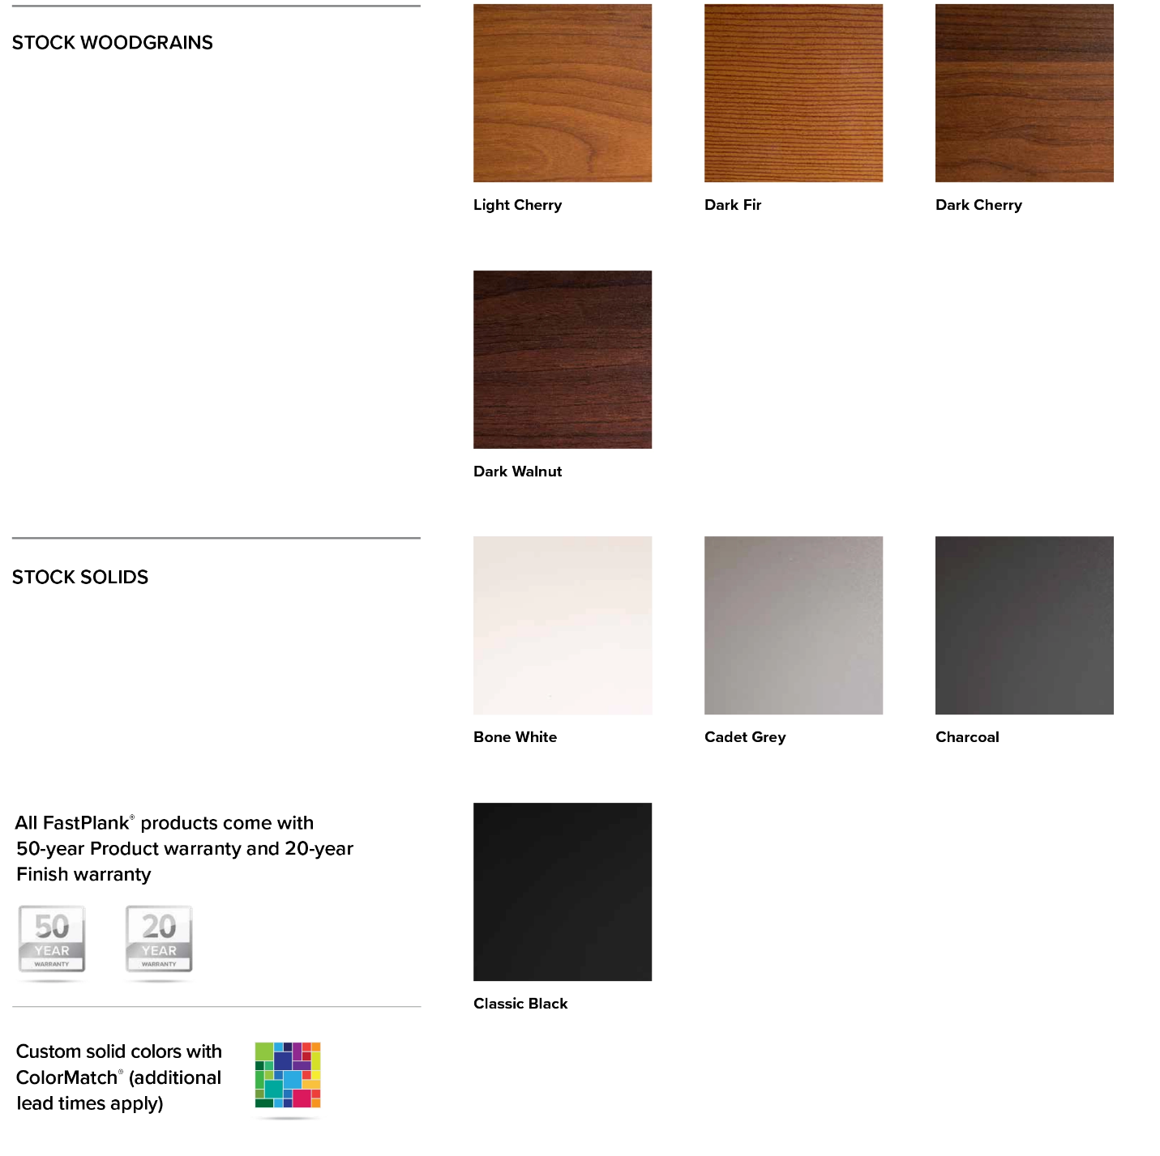

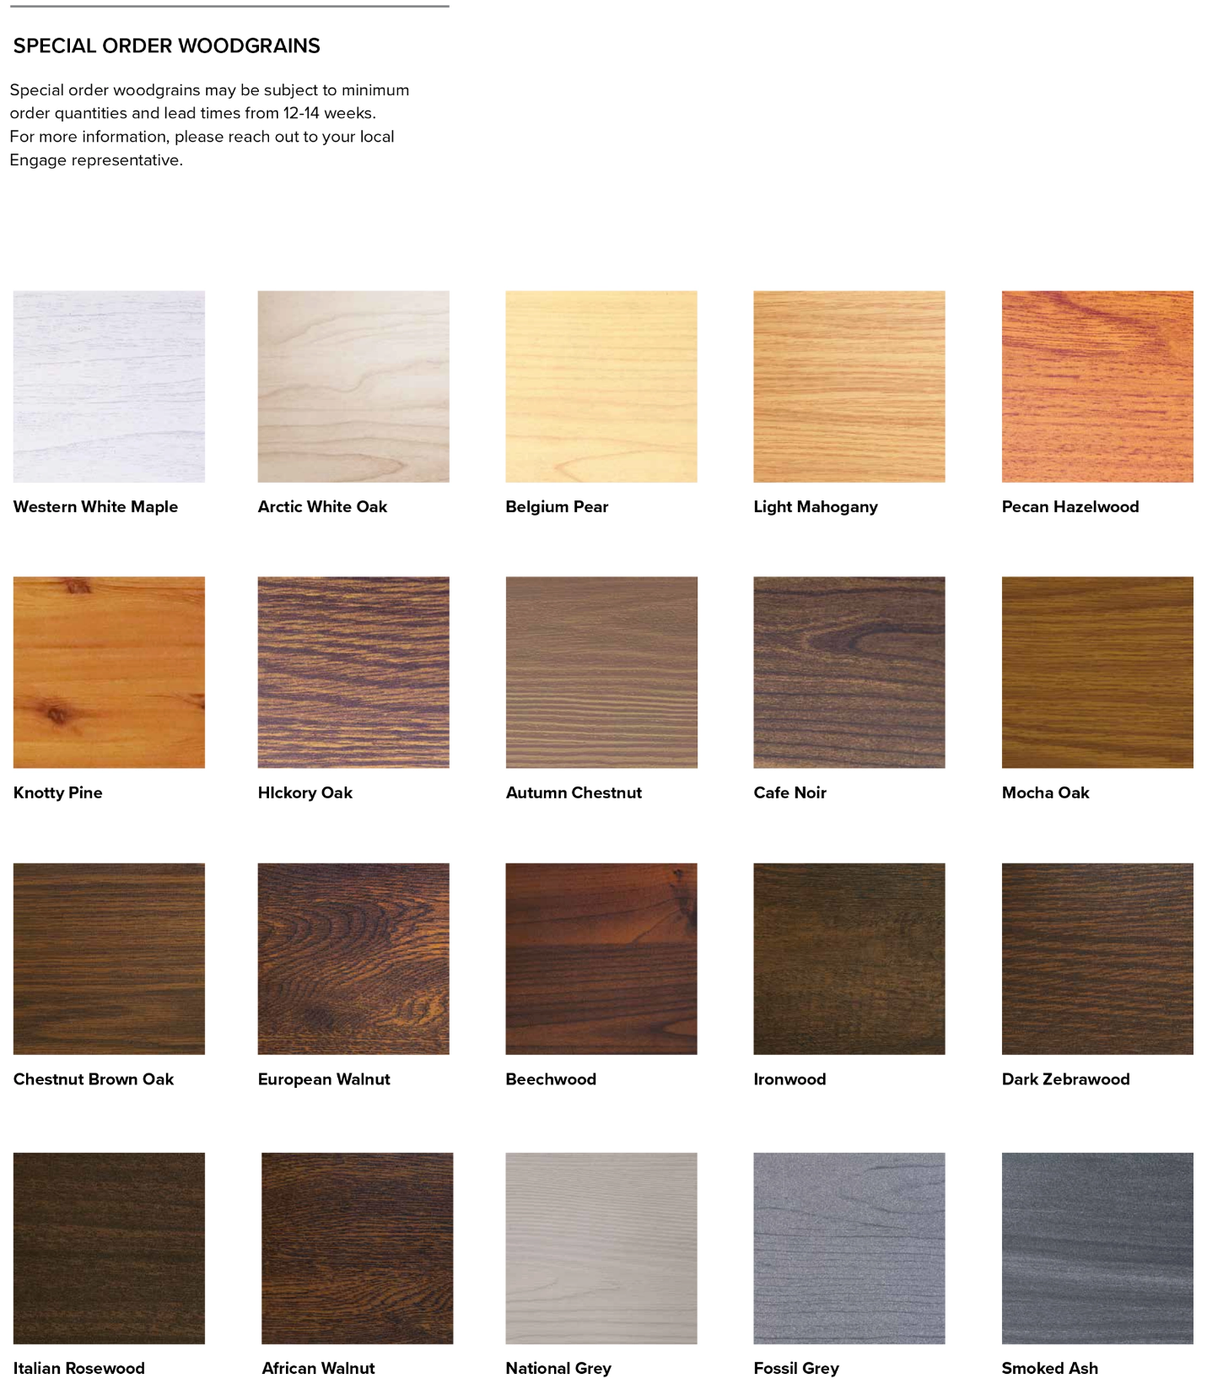
Speak with an Expert
Get personalized advice and expert guidance to achieve your project goals with confidence.

